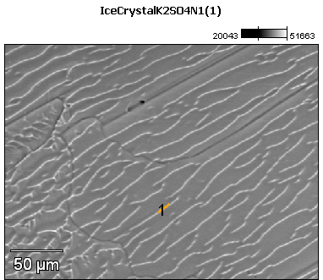

Image Name: IceCrystalK2SO4N1(1)

Image Resolution: 512 by 384

Image Pixel Size: 0.59 µm

Acc. Voltage: 12.0 kV

Magnification: 420

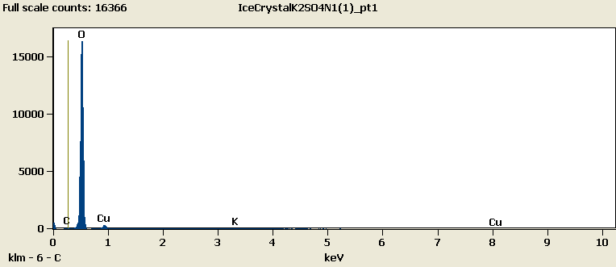

Weight %

|  |  |  |  |  |
| --- | --- | --- | --- | --- |
|  | ***C-K*** | ***O-K*** | ***K-K*** | ***Cu-L*** |
| ***IceCrystalK2SO4N1(1)_pt1*** | 0.02 | 88.09 | 0.69 | 11.20 |

Weight % Error (+/- 1 Sigma)

|  |  |  |  |  |
| --- | --- | --- | --- | --- |
|  | ***C-K*** | ***O-K*** | ***K-K*** | ***Cu-L*** |
| ***IceCrystalK2SO4N1(1)_pt1*** | ±0.10 | ±0.32 | ±0.08 | ±0.28 |

# Cations

|  |  |  |  |  |
| --- | --- | --- | --- | --- |
|  | ***C-K*** | ***O-K*** | ***K-K*** | ***Cu-L*** |
| ***IceCrystalK2SO4N1(1)_pt1*** | 0.00 | 0.00 | 0.00 | 0.00 |